Network Architecture and Protocol Lab

Booklet 3
Submitted by: Jamil Ahmed
Neptun Code: JZT75Y

4.1
A) Network Traffic Analysis
- Total size of captured frames = 132402 bytes
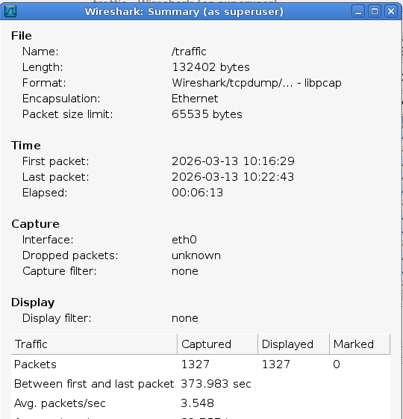

- Average bandwidth of traffic for 6 seconds:
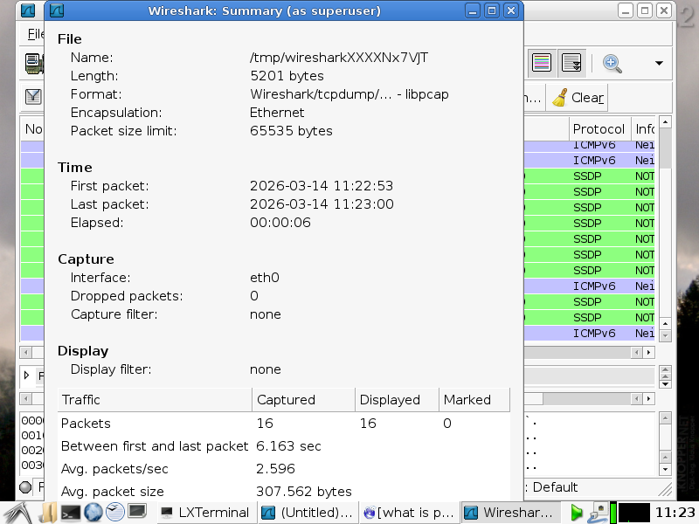
Total bytes captured during 6 seconds = 5201 bytes
Bandwidth = 5201 / 6 = 867 Bps

- Total frames captured in 6 seconds: 16
- Average frame size = 5201 / 16 = 325 bytes

B) Compression Ratio of Capture Files
I have exported the Wireshark captured files in different formats.
File types | File size (KB)
TXT | 1454
PCAP | 472.5
PCAPNG | 483

- Compression ratio in the case of PCAP and TXT: 1454 / 472.5 = 3.07
TXT : PCAP = 3 : 1
- Compression ratio in the case of PCAPNG and PCAP: 483 / 472.5 = 1.02
PCAPNG : PCAP = 1 : 1

4.2
A) Protocol Traffic
- Time diagram of different protocol traffics:
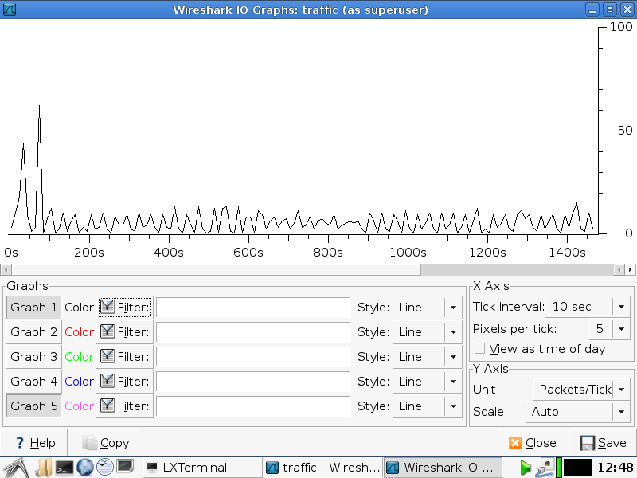

- OUI of Cisco Company: E8-0A-B9. (The company has over 1200 OUI registered with the IEEE)
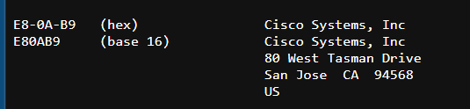
- MAC Address of the NIC module of my PC: 80:C0:1E:03:A5:5C
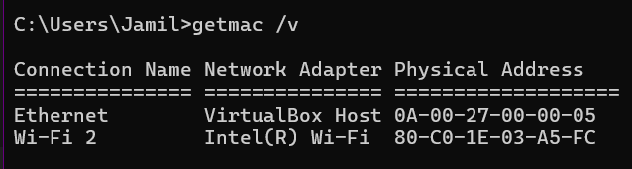

B) NIC MAC Value Identification
- MAC OUI identifiers can be found on the official website of the IEEE.
  - The website link: https://standards.ieee.org
- MAC OUI codes of manufacturers:
Company | OUI
Cisco | 00:1B:54
HP | 3C:D9:2B
Apple | F0:18:98
Xiaomi | 64:09:80
Huawei | 00:9A:CD

4.3
A) Capture rule filtering traffic from the PC
To capture only packets related to the PC, the capture filter uses the host IP address.
Capture filter: host 192.168.0.1
B) Capture rule for broadcast frames
Broadcast MAC address: FF:FF:FF:FF:FF:FF
Capture filter: ether broadcast

4.4
A) Display rule filtering traffic from the PC
ip.addr == 192.168.0.1
B) Display rule for broadcast frames
eth.dst == ff:ff:ff:ff:ff:ff

4.5
A) Where to find the tail of the captured frame
The tail of the frame is visible in the Packet Bytes panel at the bottom of Wireshark. The last bytes in the packet data represent the tail of the frame.
B) Meaning of ".." characters in the bottom field
The bottom panel shows the packet bytes in hexadecimal and ASCII format. When Wireshark displays “.” it means it is a non-printable binary data.

